Chapter 1
The Policy and Practice of Macroeconomics

Chapter Outline, Overview, and Teaching Tips

Chapter Outline

The Practice of Macroeconomics

The Process: Developing Macroeconomic Models

The Purpose: Interpreting Macroeconomic Data

Macroeconomic Policy

How Can Poor Countries Get Rich?

Is Saving Too Low?

Do Government Budget Deficits Matter?

How Costly Is It to Reduce Inflation?

How Can We Make Financial Crises Less Likely?

How Active Should Stabilization Policy Be?

Should Macroeconomic Policy Follow Rules?

Are Global Trade Imbalances a Danger?

How We Will Study Macroeconomics

Emphasis on Policy and Practice

Concluding Remarks

Chapter Overview and Teaching Tips
The first chapter of this textbook has several objectives. The first is to convince students that macroeconomics is worth studying. This chapter pursues this goal by showing the student that macroeconomics is an exciting field because it focuses on phenomena that affect everyday life. A second objective of the chapter is to help the student understand what the practice of macroeconomics is all about and what central policy issues are addressed in the study of macroeconomics. Finally, the chapter provides an overview for the entire book, previewing the topics that will be covered in later chapters. The chapter also provides students with a guide as to how they will be studying macroeconomics, by explaining and developing macroeconomic models and then applying these models to understand the policy and practice of macroeconomics.
In teaching this chapter, the most important goal should be to motivate students by getting them excited about what they are about to learn. I have found that there are two ways to do this. First is to talk about the basic macroeconomic data in Figures 1.2 to 1.10 and explain that numerous real world applications in the book will be used to show how macroeconomic analysis can explain this data. Second is to have the students give their initial reactions to the eight basic policy questions posed in the chapter: How can poor countries get rich? Is saving too low? Do government budget deficits matter? How costly is it to reduce inflation? How can we make financial crises less likely? How active should stabilization policy be? Should macroeconomic policy follow rules? Are global trade imbalances a danger?
Once they have given their initial views, the instructor can tell the students that they will have much clearer understanding of these issues when they have finished the course and will have mastered analytic frameworks that can help them have informed views about the issues.

Answers to End of Chapter Review Questions and Problems

Answers to Review Questions

Preview

1. Economic growth, labor market conditions (the unemployment rate and growth in the number of jobs), inflation, the value of the U.S. dollar, and changes in economic policy measures such as interest rates and tax rates all will have significant impacts on your future.

The Practice of Macroeconomics

2. Endogenous variables are the variables whose behavior a model seeks to explain. Changes in the values of these variables are explained in terms of changes in exogenous variables, whose values are not explained by the model but instead are determined outside the model and taken as given. For example, an economist might build a model to explain why inflation rates differ over time and across countries based on changes in money supply growth. In this model, the inflation rate is the endogenous variable, and money supply growth is the exogenous variable.

3. First, identify the question of interest and decide which endogenous variables the model will seek to explain. Then decide which exogenous variables will be used to explain the endogenous variables of interest. Third, express the model in equation or graphic form that will relate changes in the endogenous variables to changes in the exogenous ones. Fourth, compare the predictions of the model with data for the endogenous and exogenous variables. Finally, if the model fits (explains) the data well, use it to make predictions and analyze policy. If it doesn’t explain the data well, then revise the model and try again.

4. Real gross domestic product, which measures an economy’s aggregate output, is important because it gives information about both long-term growth and short-run fluctuations of output. The unemployment rate measures how fully labor resources are being used in the economy and how widespread the economic hardship experienced by unemployed workers may be. The inflation rate gives an overall measure of how rapidly prices are rising and signals how serious the costs of inflation may be at any given time.

5. The business cycle is a sequence of recurring but irregular fluctuations in economic activity. A recession is the period of the business cycle during which economic activity is declining. Macroeconomists study business cycles and are particularly concerned with the causes of recessions and depressions.

6. During periods of inflation, the overall level of prices rises. It falls during deflationary periods.

Macroeconomic Policy

7. A nation’s saving rate is the percentage of income that is saved each year. Nations with higher saving rates tend to also have higher investment levels, which promotes their economic growth. A higher saving rate also means that individuals and households will be better prepared to cope with the potentially severe financial problems they may encounter during a recession. Government policies may encourage or discourage saving and the saving rate. All these factors make the saving rate an important macroeconomic concern.

8. When government has a budget deficit, it is spending more than the tax revenues it collects and, therefore, must borrow money and go deeper into debt. Macroeconomists have concerns about the size of budget deficits, the burden deficits may impose on future generations facing higher taxes to pay off the government’s debt, and the inflation that may result if a government decides to print more money to cover its deficit and debt. The degree of these concerns increases with the size of the budget deficit.

9. Fiscal policy refers to a government changing its taxes or spending or both. Monetary policy is a central bank’s control of interest rates and the amount of money in an economy. These policies are used for such purposes as influencing an economy’s saving rate, reducing or expanding the size of a government’s budget deficit, influencing the inflation rate and unemployment rate in an economy, or limiting business cycle fluctuations and stabilizing economic activity.

10 Stabilization policy is the use of fiscal and monetary policies to stabilize economic activity by reducing business cycle fluctuations. One debate concerns how active stabilization policy should be. It pits nonactivists, macroeconomists who believe that the economy has a self-correcting mechanism that works rapidly to reduce unemployment without the need for stabilization policy, against activists,
who think this self-correcting mechanism is too slow and therefore call for the active use of fiscal
and monetary policies to reduce unemployment when it is unacceptably high. A second debate arises between macroeconomists who advocate the use of policy rules to specify in advance precisely
how policymakers must react to changes in unemployment or inflation and those who would allow policymakers greater latitude to use their discretionary judgment to formulate the policy response they believe is most appropriate in a given situation.

11 Global trade imbalances occur when some countries run large trade deficits and become increasingly indebted to and dependent on large capital inflows from other countries that are running large trade surpluses. These imbalances are not sustainable in the long run. Economists focus on them because a ready supply of funds from abroad can result in too much investment in particular asset markets, and if the flows are reduced suddenly, it can lead to financial crises, which have detrimental effects on economic activity.

Answers to Problems

The Practice of Macroeconomics

1. a. The endogenous variable is the variable explained by your model, in this case, the prevalence of diabetes in children. The exogenous variable is a variable that is determined outside the model and that presumably has an impact on the endogenous variable. In this case, a child’s weight would be the exogenous variable.

b. Other exogenous variables should include factors that one way or another might contribute to diabetes: hours of exercise, income level, education, etc. Choosing the proper exogenous variables and testing their effects is an important part of advancing scientific knowledge.

2. A model is as good as its predictive power, in terms of explaining both previous and future changes in the explained variable. If a current model does not “fit the data,” meaning that it cannot replicate current trends in diabetes prevalence, then the researcher has to go back to step 2 and look for other explanatory variables. This process should be repeated until the model can explain current trends and, therefore, can be used to predict future changes.

3. a. According to the graph, Spain’s real GDP growth rate decreased from the first quarter of 2007 until the third quarter of 2009. After that the growth rate rose but reached a peak of only 0.6 percent in the third quarter of 2011 and then turned negative again in 2012. Thus, the overall trend for the Spanish growth rate has been downward.

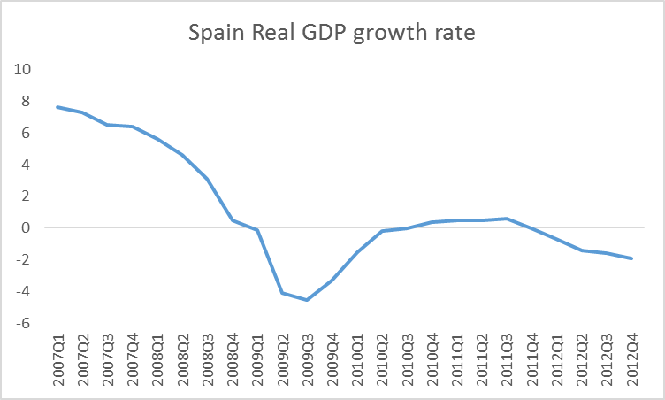

b. According to data, Spain experienced a recession from the first quarter of 2009 until the third quarter of 2010. However, Spain entered another recession in the first quarter of 2012, when its real GDP growth rate again became negative. Although the real GDP growth rate is not the only indicator of a recession, it usually moves together with other indicators such as the unemployment rate or investment.

4. Although unemployment definitely has negative consequences in terms of decreased production
of goods and services, that is not the only reason why it is such an important macroeconomic topic. Most modern societies are structured based on the idea that individuals need a job to provide for themselves and their families. An individual’s inability to find a job will have important psychological (e.g., depression, lack of confidence) and social (e.g., rejection, lower status) consequences. These considerations will play a crucial role in evaluating potential solutions to mitigate these negative effects (e.g., unemployment insurance).

Macroeconomic Policy

5. Budget deficits by themselves are not inherently good or bad. However, as we will study later, they can be the source of inflation if governments pay for a budget deficit by printing money. Very high inflation rates (sometimes in excess of 50 percent per month) have a disastrous effect on any economy. High inflation rates decrease incentives to invest and distort relative prices, making economic decisions more difficult. High inflation rates for a sustained period eventually translated into stagnating or decreasing real GDP growth rates in Latin American countries, making this experience an example to avoid. Subsequent (and costly) economic reforms put these countries on the right track again, mostly by reducing budget deficits and inflation.

6. a. The immediate effect of the destruction created by a civil war is a decrease in the economy’s ability to produce goods and services. Goods cannot be moved from producer to buyers, and fewer individuals are able or willing to work during a civil war, decreasing the labor force and work opportunities. Countries with a history of frequent civil wars have significantly lower real GDP growth rates than countries with more stable political regimes.

b. A civil war kills incentives to invest, which implies postponing present consumption and putting resources away in order to increase future consumption. The chaos and uncertainty created by a civil war increase incentives for present consumption and, therefore, result in lower economic growth. As we will study later, investment is a major driving force for economic growth.

7. As a financial crisis develops, businesses find it more difficult to get access to external funds and, therefore, cannot meet their obligations. This results in business failures as well as rising unemployment. At the same time, the decrease in asset prices translates into a decrease in consumption expenditures, decreasing demand for most goods and services. Businesses respond by firing workers, which increases unemployment even more. It is now more difficult to create new jobs, as credit is restricted and demand is uncertain, which decreases investment and, therefore, directly affects economic growth. Financial crisis are usually associated with decreases in real GDP.

8. The fact that Americans currently are not saving enough might have very important implications for future generations. One of them is that future generations might face higher taxes than present generations to pay for the debt accumulated to allow higher current consumption by the present generation. Higher future taxes might result in lower standards of living, as future generations will have to set aside a higher percentage of their income to pay for taxes. Another implication of this situation is that future generations should expect to receive less help from their children to support them when they retire. This follows from the fact that their children will probably face higher taxes. We will later study the different policies that can affect incentives to save for the future.

9. According to the post, the American Recovery and Reinvestment Act was a policy instrument designed to affect the economic environment and lift the American economy from its recession. This constitutes a typical activist policy, in which the government takes action using either fiscal or monetary policies (or both) to spur consumption and investment and create jobs. Not surprisingly, many nonactivist policymakers criticized the current administration for following this path, arguing that such a set
of policies will do more harm than good to the economy. The debate about activist and nonactivist policy is fascinating and will be discussed later.

10. There is little doubt that actions taken by the Federal Reserve (some of them in coordination with the U.S. Treasury) in the aftermath of the subprime financial crisis were necessary to restore confidence in the U.S. financial system. A significant part of these actions involved providing liquidity to different participants in the financial system. This fueled fears of higher inflation rates in the future, as persistent increases in the money supply usually result in high inflation rates, as will be discussed later. Inflation, however, remained at low rates during 2008 and 2009, and expected inflation rates did not increase significantly, as detractors of the Federal Reserve’s approach forecasted. The relationship between monetary policy and inflation is far from simple. However, it is crucial to understand the effects of monetary policy on inflation because high inflation can be detrimental for economic growth.

11. a. The American Recovery and Reinvestment Act of 2009 can be considered an example of discretionary macroeconomic policy. It was essentially a set of policies intended to support economic agents affected by the subprime financial crisis and to promote economic recovery.

b. One of the fears related to conducting discretionary policy is that agents will come to expect that the government will react to accommodate unusual economic downturns. This becomes a problem when financial intermediaries expect government assistance when there is a financial crisis. It also affects incentives for households that come to expect some type of support during contractions. In this sense, this problem looks very much like raising children: If kids expect to be “bailed out” when they do not behave as asked, then it is quite possible that their incentives to behave properly decrease. From the point of view of financial intermediaries, this would mean that they do not have a huge incentive to appropriately price risks.

Answers to Data Analysis Problems

1. PINCOME is exogenous, and PCEC is endogenous; M1SL and PAYEMS are unrelated; GS10 is exogenous, and PSAVERT is endogenous. Scatterplots are shown below.

2. Data from 2000 Q1 to 2013 Q1 are shown below, with recessions highlighted.

a. The highest inflation rate was 4.2percent in the third quarter of 2008. The lowest was
–0.8 percent in the third quarter of 2009. Deflation occurred in the second and third quarter of 2009.

b. The highest GDP growth rate was 5.4 percent in the second quarter of 2000. The lowest growth rate was –4.6 percent in the second quarter of 2009.

c. In general, the periods of recession tend to have the lowest inflation rates and the lowest GDP growth rates.
Date | PCE Inflation Rate | GDP Growth Rate
2000-01-01 | 2.6 | 4.2
2000-04-01 | 2.4 | 5.4
2000-07-01 | 2.5 | 4.1
2000-10-01 | 2.5 | 2.9
2001-01-01 | 2.3 | 2.3
2001-04-01 | 2.3 | 1.0
2001-07-01 | 1.8 | 0.6
2001-10-01 | 1.3 | 0.4
2002-01-01 | 0.8 | 1.6
2002-04-01 | 1.1 | 1.5
2002-07-01 | 1.6 | 2.3
2002-10-01 | 2.0 | 1.9
2003-01-01 | 2.5 | 1.5
2003-04-01 | 1.8 | 1.8
2003-07-01 | 1.9 | 3.0
2003-10-01 | 1.9 | 3.9
2004-01-01 | 2.0 | 4.1
2004-04-01 | 2.7 | 3.9
2004-07-01 | 2.7 | 3.0
2004-10-01 | 3.0 | 2.9
2005-01-01 | 2.8 | 3.3
2005-04-01 | 2.7 | 3.1
2005-07-01 | 3.2 | 3.1
2005-10-01 | 3.2 | 2.8
2006-01-01 | 3.1 | 3.0
2006-04-01 | 3.2 | 3.0
2006-07-01 | 2.8 | 2.2
2006-10-01 | 1.9 | 2.4
2007-01-01 | 2.4 | 1.2
2007-04-01 | 2.5 | 1.7
2007-07-01 | 2.4 | 2.5
2007-10-01 | 3.5 | 2.2
2008-01-01 | 3.4 | 1.6
2008-04-01 | 3.7 | 1.0
2008-07-01 | 4.2 | –0.6
2008-10-01 | 1.7 | –3.3
2009-01-01 | 0.2 | –4.2
2009-04-01 | –0.5 | –4.6
2009-07-01 | –0.8 | –3.3
2009-10-01 | 1.4 | –0.1
2010-01-01 | 2.4 | 1.9
2010-04-01 | 2.1 | 2.5
2010-07-01 | 1.7 | 2.8
2010-10-01 | 1.5 | 2.4
2011-01-01 | 1.8 | 1.8
2011-04-01 | 2.6 | 1.9
2011-07-01 | 2.8 | 1.6
2011-10-01 | 2.5 | 2.0
2012-01-01 | 2.4 | 2.4
2012-04-01 | 1.6 | 2.1
2012-07-01 | 1.5 | 2.6
2012-10-01 | 1.6 | 1.7
2013-01-01 | 1.2 | 1.8

3. a. Germany experienced the highest unemployment rate in 2005 at 11.2 percent; Japan experienced the lowest unemployment rate in 2007 at 3.6 percent.

b. During years of recession shown in the table, the average unemployment rate is 6.6 percent. When not in recession, the unemployment is lower at 6.2 percent. This is expected because the unemployment rate rises during recessions and falls during expansions.

c. There are clear similarities between the unemployment rates of the United States, Canada, United Kingdom, and Japan. They generally move up and down together. The outlier is Germany, which experienced much higher unemployment than the other countries but has had steady declines in their unemployment rate while many others have experienced high unemployment from the last recession.
Graph and table are shown below, from 2000 to 2012. The bold indicates a year in which the United States was in recession.

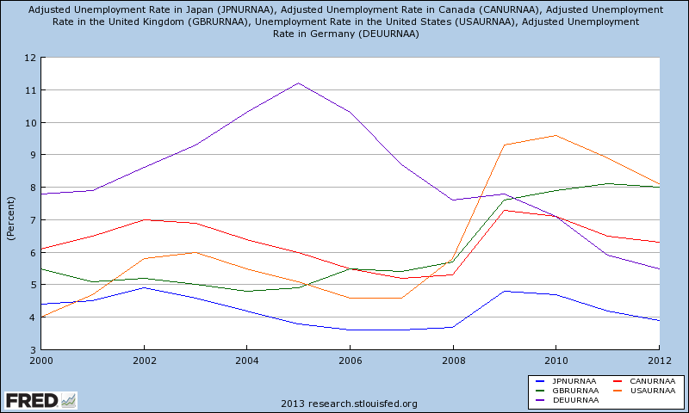

Date | United States | Canada | United Kingdom | Japan | Germany
2000-01-01 | 4.0 | 6.1 | 5.5 | 4.4 | 7.8
2001-01-01 | 4.7 | 6.5 | 5.1 | 4.5 | 7.9
2002-01-01 | 5.8 | 7.0 | 5.2 | 4.9 | 8.6
2003-01-01 | 6.0 | 6.9 | 5.0 | 4.6 | 9.3
2004-01-01 | 5.5 | 6.4 | 4.8 | 4.2 | 10.3
2005-01-01 | 5.1 | 6.0 | 4.9 | 3.8 | 11.2
2006-01-01 | 4.6 | 5.5 | 5.5 | 3.6 | 10.3
2007-01-01 | 4.6 | 5.2 | 5.4 | 3.6 | 8.7
2008-01-01 | 5.8 | 5.3 | 5.7 | 3.7 | 7.6
2009-01-01 | 9.3 | 7.3 | 7.6 | 4.8 | 7.8
2010-01-01 | 9.6 | 7.1 | 7.9 | 4.7 | 7.1
2011-01-01 | 8.9 | 6.5 | 8.1 | 4.2 | 5.9
2012-01-01 | 8.1 | 6.3 | 8.0 | 3.9 | 5.5

4. a. The United States has the highest standard of living according to the data; China has the lowest among the five.

b. South Korea’s standard of living has steadily improved over time and has closed a significant gap with Japan and the United Kingdom. In 1990, the gap was $17,694 per person compared to Japan and $12,794 per person compared to the United Kingdom; in 2011, the gap shrunk to $4,040 and $5,434 per person, respectively.

c. Although China’s standard of living is much lower overall, it has grown rapidly during the last two decades, from around $674 per person in 1990, to almost $4,500 per person in 2011, a 563 percent increase; South Korea has the next highest growth over that period (152 percent), followed by the United Kingdom (44 percent), United States (33 percent), and Japan (16 percent).

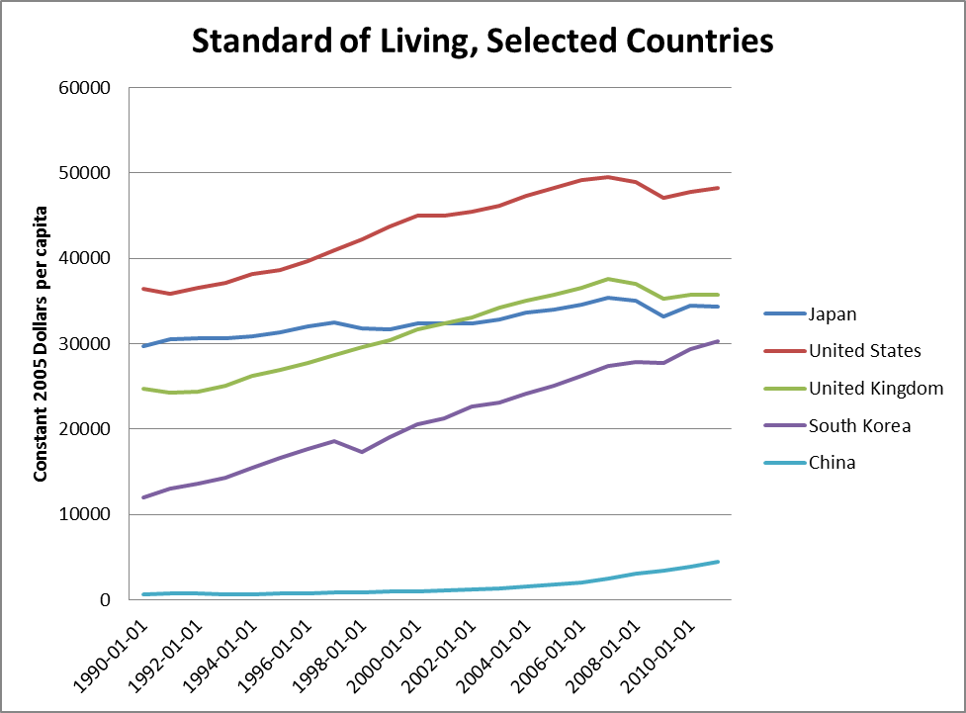

Data Sources, Related Articles, and Discussion Questions

A. For Information About Nominal and Real GDP

Data Sources
Bureau of Economic Analysis: http://www.bea.gov/ . BEA is an agency of the Department of Commerce. Along with the Census Bureau and STAT-USA, BEA is part of the department’s Economics and Statistics Administration. BEA produces economic accounts statistics that enable government and business decision makers, researchers, and the American public to follow and understand the performance of the nation’s economy. To do this, BEA collects source data, conducts research and analysis, develops and implements estimation methodologies, and disseminates statistics to the public.

Related Articles
Henderson, David R., “GDP Fetishism”: http://www.econlib.org/library/Columns/y2010/HendersonGDP.html#. This article analyzes GDP’s methodology and economists’ reliance on such measure.

Discussion Questions
Do you think GDP is a good measure of individuals’ well-being? Why or why not?
Answer: In general, there is some consensus about the fact that GDP is not a perfect measure of individual well-being. Many methodological (i.e., measurement) problems plague this approach to measuring economic activity (or a nation’s income). However, the GDP measure has some advantages, like allowing cross-country comparisons and being highly correlated with other measures of individual welfare.

B. For Information About Inflation and Unemployment

Data Source
Bureau of Labor Statistics: http://www.bls.gov/. The Bureau of Labor Statistics is the principal fact-finding agency for the federal government in the broad field of labor economics and statistics. BLS is an independent national statistical agency within the Department of Labor that collects, processes, analyzes, and disseminates essential statistical data to the American public, congress, other federal agencies, state and local governments, business, and labor. BLS also serves as a statistical resource to the Department of Labor.

Related Article
Summers, Lawrence H., “Unemployment”: http://www.econlib.org/library/Enc/Unemployment.html. This article discusses how unemployment is measured and how unemployment figures should be interpreted.

Discussion Question
Discuss the implications of a decrease in the official unemployment rate for teenagers.
Answer: The official unemployment rate is an average for all participants of the U.S. labor force. Although a decrease in the official unemployment rate might seem like good news for teenagers, one should check the unemployment rate for teenagers. The latter is usually higher than the former, meaning that teenagers suffer from higher unemployment rates than the rest of the population.

C. For Information About the Policy and Practice of Macroeconomics

Data Source
Information about macroeconomic variables (e.g., GDP, inflation, unemployment, savings rate) can be found at: http://research.stlouisfed.org/fred2/. This is a comprehensive database created and updated by
the Federal Reserve Bank of St. Louis.

Related Articls
Library of Economics and Liberty search page:
http://www.econlib.org/cgi-bin/searchbooks.pl?query=scientific+method&andor=and (check the following authors: Mill, Marshall, and Say).

Discussion Question
What is the object of studying the science of economics in general and macroeconomics in particular?
Answer: In general, the science of economics studies how individuals (or societies) allocate scarce resources to multiple ends. This implies identifying the relevant constraints and preferences (including incentives) that guide our decisions. Macroeconomics deals with topics that affect the whole economy (e.g., the role of the government, economic growth, monetary economics, unemployment, and inflation). Macroeconomics’ methodology is mostly borrowed from microeconomic analysis.

D. For Information About the Dating of Business Cycles

Data Source
The National Bureau of Economic Research: http://www.nber.org/. Founded in 1920, the National Bureau of Economic Research is a private, nonprofit, nonpartisan research organization dedicated to promoting a greater understanding of how the economy works. The NBER is committed to undertaking and disseminating unbiased economic research among public policymakers, business professionals, and the academic community.

Related Article
Krugman, Paul, “The Third Depression”: http://www.nytimes.com/2010/06/28/opinion/28krugman.html.
In this article, Nobel Prize winner Paul Krugman describes the effects of the most recent recession and comments on the policy measures designed to reduce its adverse effects.

Discussion Question
Using data from the NBER, the BLS, and the BEA, characterize the 2007–2009 recession in terms of duration, changes in unemployment, inflation, and real GDP.
Answer: According to the NBER, the last recession lasted for 18 months: December 2007 until June 2009. During this period, unemployment increased from 5.0 percent to 9.5 percent, monthly inflation rates remained low (around 0.4 on average) and were negative at some point. Finally, real GDP dropped by 4.1 percent during the 18-month period.

